**Week 1 M1: Assignment:  
GitHub Repository Setup**

Juan Macias Vasquez

Bellevue University

CSD402-H323 Java for Programmers (2261-DD)

**Jack Lusby**

August 17th, 2025

Module 1.2 Assignment GitHub

GitHub Repository Link:

<https://github.com/Juan551School/csd-402>

Screenshot of your local directory

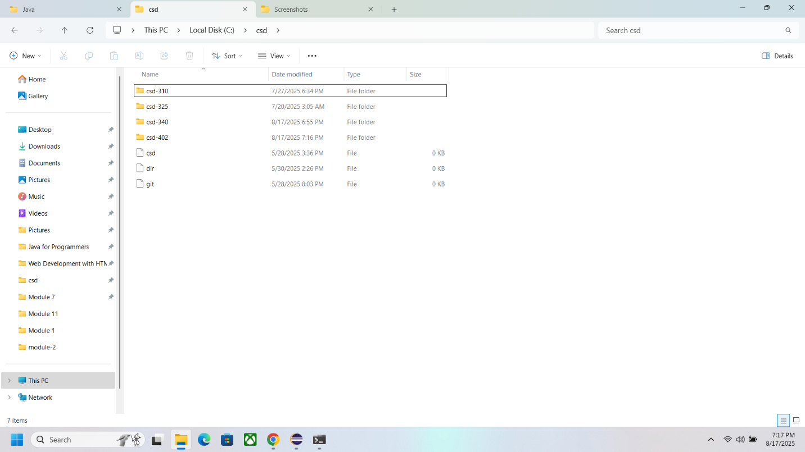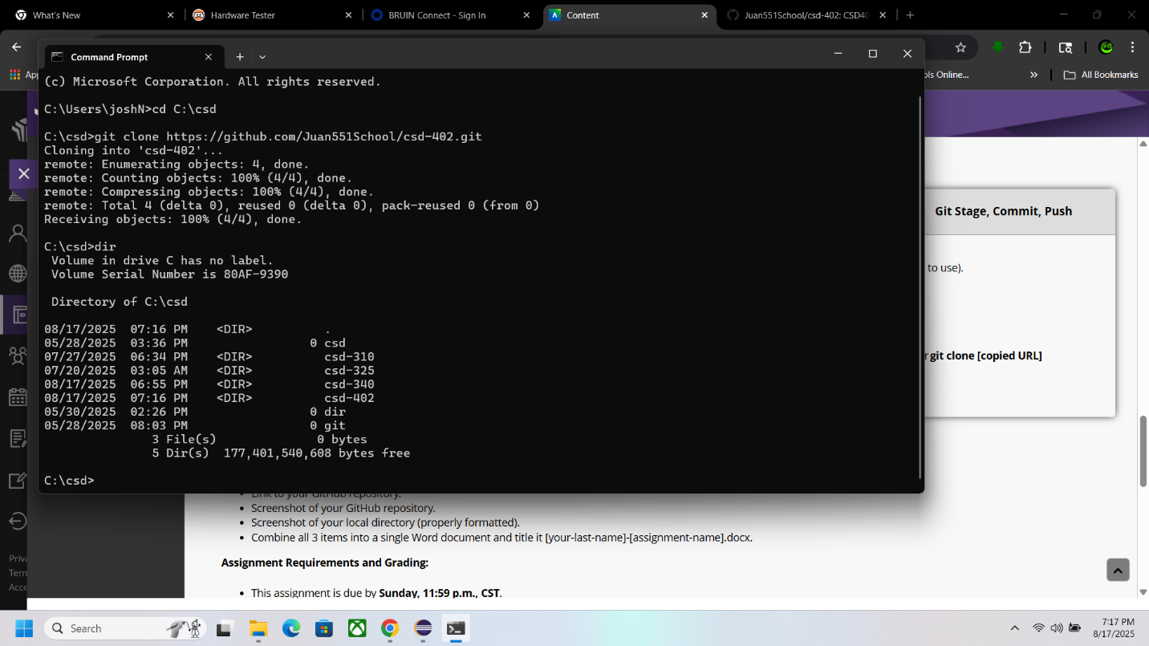

Screenshot of your GitHub repository

